Machine Project Specifications

Jungle King is a turn-based two-player board game. The board is a 9 × 7 grid. On each side of the board are the home bases surrounded by traps. There are two small lakes in the middle of the board.

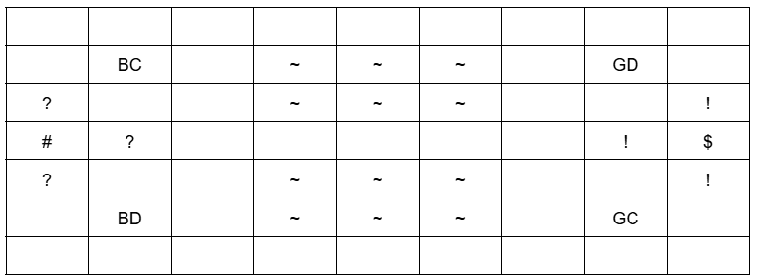

‘~’ represent the lake tiles.

Representations for Player 1 (Blue): ‘#’ for Home Base, ‘?’ for traps, ‘BD’ for Dog, and ‘BC’ for cat.

Representations for Player 2 (Green): ‘$’ for Home Base, ‘!’ for traps, ‘GD’ for Dog, and ‘GC’ for cat.

# The Game

Each player controls 2 animal pieces, namely dog and cat. The initial positions of the pieces are shown in the figure above.

## Player Move

On each turn, the player can choose to move one of his pieces. By default, each piece can move forward, backward, to the left, or to the right, onto an empty square immediately next to it. The dog and cat pieces of both players cannot move to the lake tiles.

## Capture

Generally, a stronger animal captures the equally strong or weaker animal. Captured pieces are removed from the board. The arrangement of animals from strongest to weakest is as follows: dog and cat. This means, the dog can capture the cat and the other player’s dog (if its turn to move) but the cat cannot capture the dog unless the dog is in the trap tile.

## The Traps

The traps limit the opponent’s attack. When an opponent piece lands on the trap, it becomes weak. This piece regains its strength once it leaves the trap. When an opponent’s piece is on the trap, any player piece occupying the neighboring square may capture the piece on the trap. When a player’s piece step into its own trap tile (home base) nothing happens just like normal tile.

## Before the Game

Two animal pieces are shuffled (dog and cat), faced down, are presented to the players. Each player is asked to select one of the eight animal pieces. The player who selected the stronger animal will be the first player.

## End Game

Game ends, when a player lands on the opponent’s home base. The player wins the game. Note that, the pieces of the player cannot land on his own home base.

## Deliverables

|  |  |
| --- | --- |
| **For each Phase**   1. UML class diagram (png file, 300ppi); 2. Java source code files of the implemented classes, with internal documentation; 3. Meaningful program documentation generated via javadoc; and 4. Test case document. | |
| **For Phase 1 Requirements:**   1. Draw the UML class diagram to represent the system described. 2. Implement only the classes that allows the dog and cat pieces to move on the board with all terrains (lake & trap). The program ends when the piece reaches the opponent’s base. 3. Phase 1 implementation requires user to enter W, A, S, D (or any other keys to indicate direction), and displaying of essential information on the console (no GUI required yet). | |

# Important Notes

1. For the minimum requirements of this MP, all the requirements written in this document should be implemented and working.
2. Do not forget to include internal documentation (comments) in your code.
3. You are required to create and use methods and classes whenever possible. Make sure to use Object-based. No brute force solution.
4. All sources should have proper citations. Citations should be written using the APA format. Examples of APA- formatted citations can be seen in the References section of the syllabus.